Internal Tangency
# Source: AI Source: Provided by: [Data Path: Persons Table -> ID Column: 1, Name_En Column: Motasem Essam] -> From: [ChatGPT] on [7/25/2026]
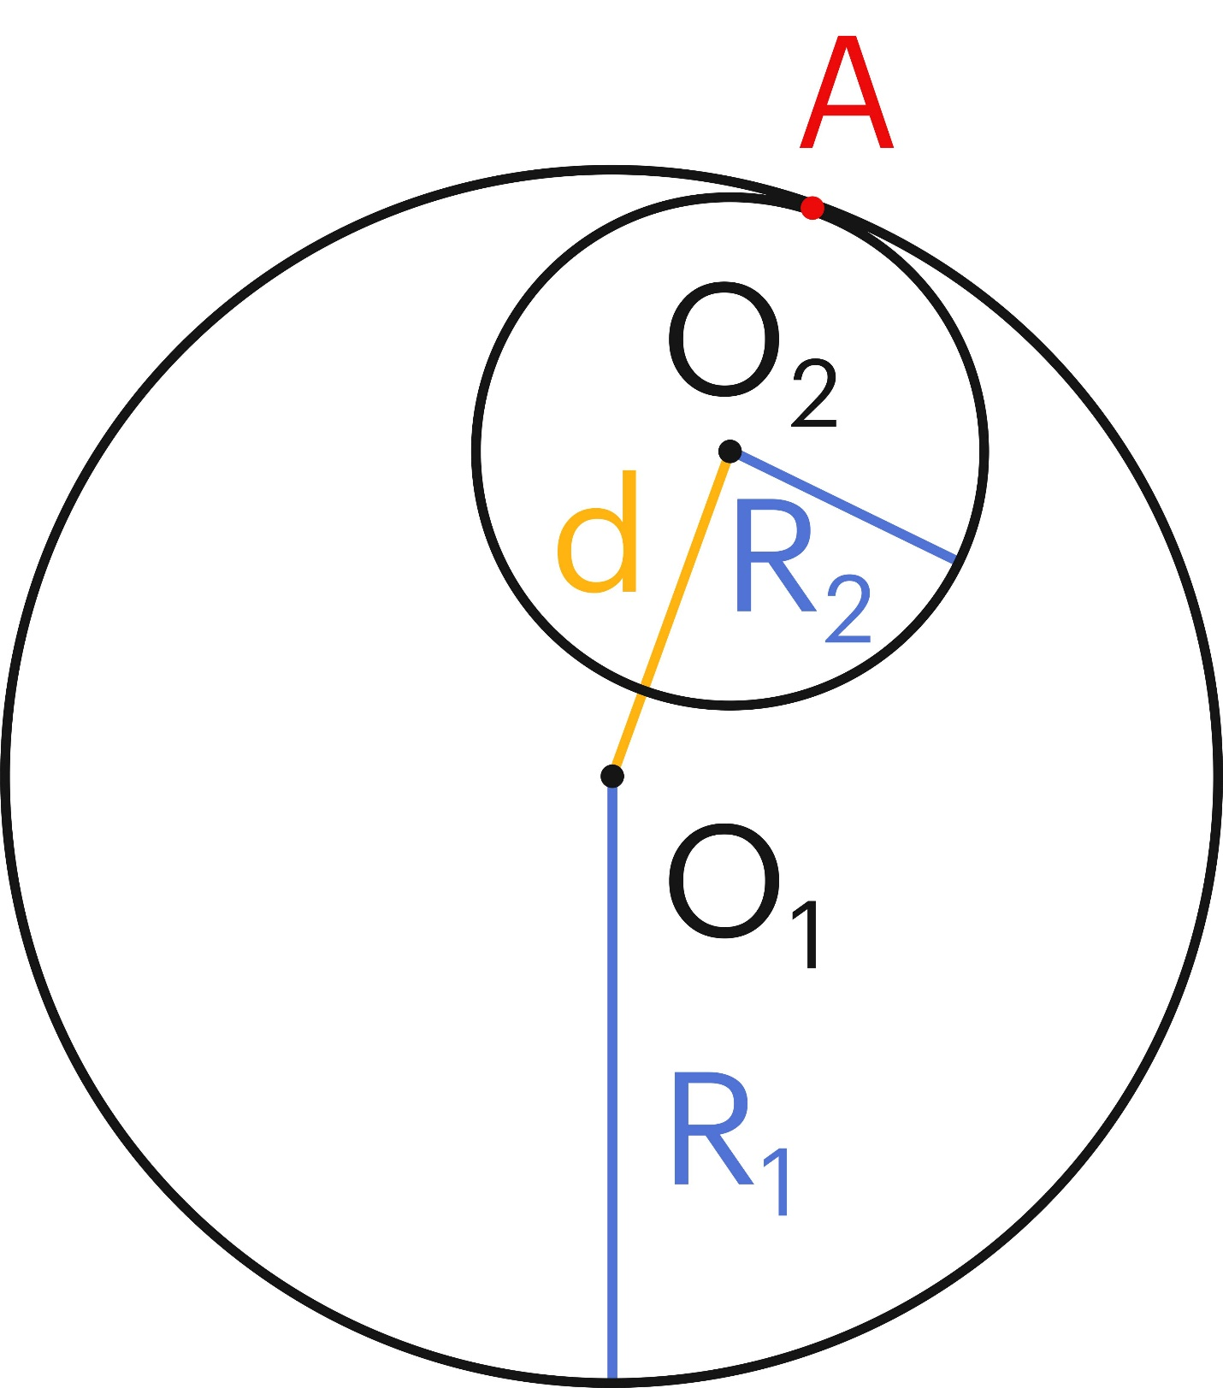
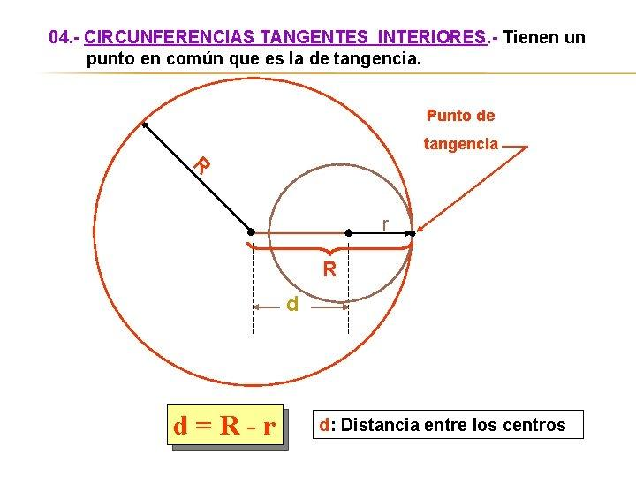
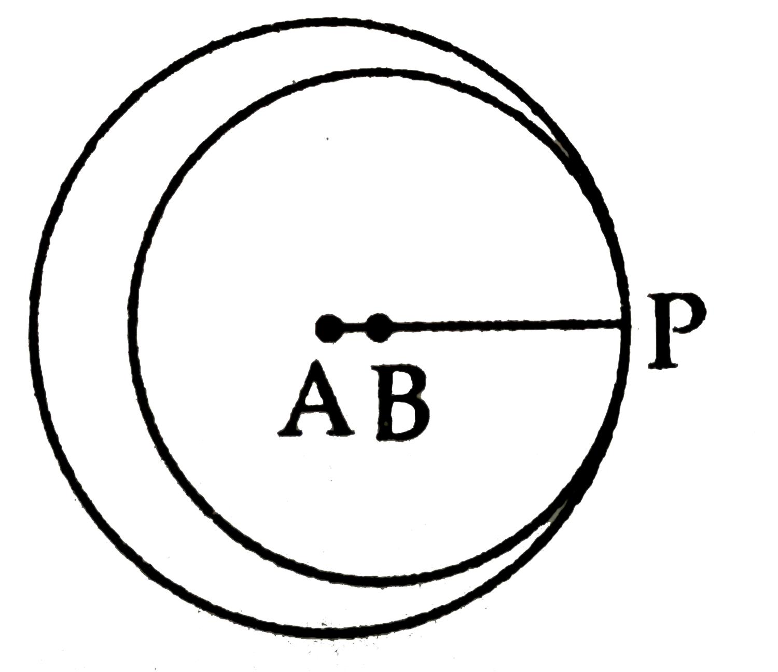

Definition
# Source: AI Source: Provided by: [Data Path: Persons Table -> ID Column: 1, Name_En Column: Motasem Essam] -> From: [ChatGPT] on [7/25/2026]
Internal Tangency is a type of Circle–Circle Tangency in which one circle lies inside another circle and the two circles touch at exactly one common point.
The common point is called the point of tangency.
If the larger circle has radius $R_{1}$, the smaller circle has radius $R_{2}$, and the distance between their centers is $d$, then:
$$\boxed{d=∣R_{1}-R_{2}∣}$$
Assuming $R_{1}>R_{2}$:
$$\boxed{d=R_{1}-R_{2}}$$

Fundamental Concept
# Source: AI Source: Provided by: [Data Path: Persons Table -> ID Column: 1, Name_En Column: Motasem Essam] -> From: [ChatGPT] on [7/25/2026]
Consider two internally tangent circles:
- $C_{1}$: larger circle
- $O_{1}$: center of the larger circle
- $R_{1}$: radius of the larger circle
- $C_{2}$: smaller circle
- $O_{2}$: center of the smaller circle
- $R_{2}$: radius of the smaller circle
- $T$: point of tangency
The smaller circle is completely inside the larger circle and touches its circumference at $T$.
The three points are collinear:
$$\boxed{O_{1}, O_{2}, T}$$
For $R_{1}>R_{2}$:
$$O_{1}O_{2}+O_{2}T=O_{1}T$$
Therefore:
$$d+R_{2}=R_{1}$$
so:
$$\boxed{d=R_{1}-R_{2}}$$

Main Parts
# Source: AI Source: Provided by: [Data Path: Persons Table -> ID Column: 1, Name_En Column: Motasem Essam] -> From: [ChatGPT] on [7/25/2026]
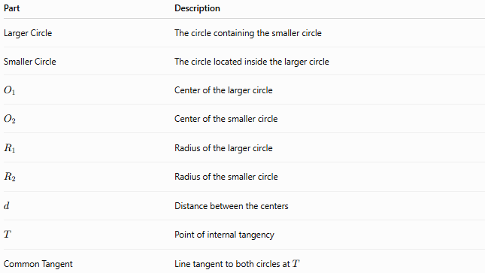
Part | Description
Larger Circle | The circle containing the smaller circle
Smaller Circle | The circle located inside the larger circle
$$O_{1}$$ | Center of the larger circle
$$O_{2}$$ | Center of the smaller circle
$$R_{1}$$ | Radius of the larger circle
$$R_{2}$$ | Radius of the smaller circle
$$d$$ | Distance between the centers
$$T$$ | Point of internal tangency
Common Tangent | Line tangent to both circles at $T$

Defining Properties

1-Exactly One Common Point
# Source: AI Source: Provided by: [Data Path: Persons Table -> ID Column: 1, Name_En Column: Motasem Essam] -> From: [ChatGPT] on [7/25/2026]
Internally tangent circles have exactly one common point:
$$\boxed{C_{1}∩C_{2}=\left\{T\right\}}$$
They do not cross each other.

2-One Circle Lies Inside the Other
# Source: AI Source: Provided by: [Data Path: Persons Table -> ID Column: 1, Name_En Column: Motasem Essam] -> From: [ChatGPT] on [7/25/2026]
The smaller circle is contained within the larger circle:
$$C_{2}⊂C_{1}$$
except that their boundaries meet at $T$.

3-Centers and Tangency Point Are Collinear
# Source: AI Source: Provided by: [Data Path: Persons Table -> ID Column: 1, Name_En Column: Motasem Essam] -> From: [ChatGPT] on [7/25/2026]
$$\boxed{O_{1}, O_{2}, T\text{ are collinear}}$$

4-Tangency Point Lies on the Same Side of Both Centers
# Source: AI Source: Provided by: [Data Path: Persons Table -> ID Column: 1, Name_En Column: Motasem Essam] -> From: [ChatGPT] on [7/25/2026]
The order of the points is:
$$\boxed{O_{1}-O_{2}-T}$$
when the smaller circle is internally tangent to the larger circle.
Thus:
$$O_{1}O_{2}=d \\ O_{2}T=R_{2} \\ O_{1}T=R_{1}$$
and:
$$\boxed{O_{1}O_{2}+O_{2}T=O_{1}T}$$

Internal Tangency Formula
# Source: AI Source: Provided by: [Data Path: Persons Table -> ID Column: 1, Name_En Column: Motasem Essam] -> From: [ChatGPT] on [7/25/2026]
The fundamental relationship is:
$$\boxed{d=∣R_{1}-R_{2}∣}$$
where:
- $d$= distance between centers
- $R_{1}$= radius of the first circle
- $R_{2}$= radius of the second circle
If $R_{1}≥R_{2}$:
$$\boxed{d=R_{1}-R_{2}}$$
Therefore:
$$\boxed{R_{1}=d+R_{2}}$$
and:
$$\boxed{R_{2}=R_{1}-d}$$

Common Tangent at the Point of Tangency
# Source: AI Source: Provided by: [Data Path: Persons Table -> ID Column: 1, Name_En Column: Motasem Essam] -> From: [ChatGPT] on [7/25/2026]
At the point $T$, both circles have the same tangent line.
The radii leading to $T$are perpendicular to this tangent:
$$\boxed{O_{1}T⊥l}$$
and:
$$\boxed{O_{2}T⊥l}$$
Therefore, the common tangent is also perpendicular to the line joining the centers:
$$\boxed{l⊥O_{1}O_{2}}$$

Coordinate Geometry
# Source: AI Source: Provided by: [Data Path: Persons Table -> ID Column: 1, Name_En Column: Motasem Essam] -> From: [ChatGPT] on [7/25/2026]
If the centers are:
$$O_{1}=\left(x_{1} , y_{1}\right)$$
and:
$$O_{2}=\left(x_{2} , y_{2}\right)$$
then the center distance is:
$$\boxed{d=\sqrt{{\left(x_{2}-x_{1}\right)}^{2}+{\left(y_{2}-y_{1}\right)}^{2}}}$$
For internal tangency:
$$\boxed{\sqrt{{\left(x_{2}-x_{1}\right)}^{2}+{\left(y_{2}-y_{1}\right)}^{2}}=∣R_{1}-R_{2}∣}$$

Position Classification of Two Circles
# Source: AI Source: Provided by: [Data Path: Persons Table -> ID Column: 1, Name_En Column: Motasem Essam] -> From: [ChatGPT] on [7/25/2026]
Assume $R_{1}>R_{2}$.
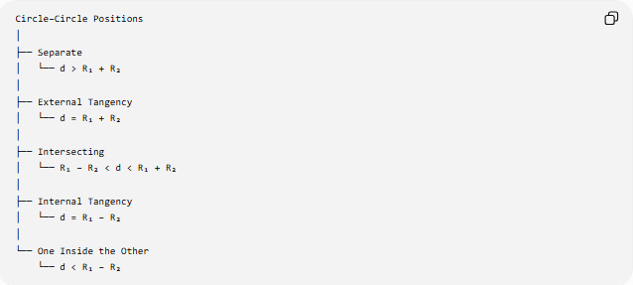
Circle–Circle Positions
│
├── Separate
│ └── d > R₁ + R₂
│
├── External Tangency
│ └── d = R₁ + R₂
│
├── Intersecting
│ └── R₁ − R₂ < d < R₁ + R₂
│
├── Internal Tangency
│ └── d = R₁ − R₂
│
└── One Inside the Other
└── d < R₁ − R₂
Internal tangency is therefore the boundary case between two intersecting circles and one circle being completely inside the other without touching.

Internal Tangency vs External Tangency
# Source: AI Source: Provided by: [Data Path: Persons Table -> ID Column: 1, Name_En Column: Motasem Essam] -> From: [ChatGPT] on [7/25/2026]
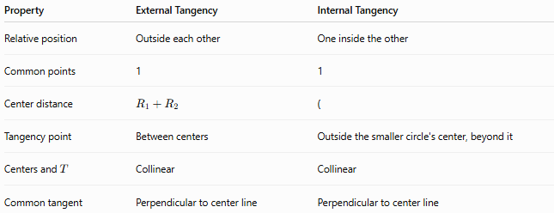
Property | External Tangency | Internal Tangency
Relative position | Outside each other | One inside the other
Common points | 1 | 1
Center distance | $$R_{1}+R_{2}$$ | (
Tangency point | Between centers | Outside the smaller circle's center, beyond it
Centers and $T$ | Collinear | Collinear
Common tangent | Perpendicular to center line | Perpendicular to center line
Formulas
External:
$$\boxed{d=R_{1}+R_{2}}$$
Internal:
$$\boxed{d=∣R_{1}-R_{2}∣}$$

Example
# Source: AI Source: Provided by: [Data Path: Persons Table -> ID Column: 1, Name_En Column: Motasem Essam] -> From: [ChatGPT] on [7/25/2026]
Suppose two circles have radii:
$$R_{1}=10\text{ cm}$$
and:
$$R_{2}=4\text{ cm}$$
For internal tangency:
$$d=R_{1}-R_{2} \\ d=10-4 \\ \boxed{d=6\text{ cm}}$$
Therefore, their centers must be 6 cm apart for the circles to be internally tangent.

Special Case: Equal Radii
# Source: AI Source: Provided by: [Data Path: Persons Table -> ID Column: 1, Name_En Column: Motasem Essam] -> From: [ChatGPT] on [7/25/2026]
If:
$$R_{1}=R_{2}$$
then internal tangency would require:
$$d=∣R_{1}-R_{2}∣=0$$
So:
$$O_{1}=O_{2}$$
The two circles would coincide rather than be two distinct internally tangent circles.
Therefore:
Two distinct circles with equal radii cannot be internally tangent.

Tangency-Point Coordinate Formula
# Source: AI Source: Provided by: [Data Path: Persons Table -> ID Column: 1, Name_En Column: Motasem Essam] -> From: [ChatGPT] on [7/25/2026]
Suppose the larger circle has center:
$$O_{1}=\left(x_{1} , y_{1}\right)$$
and radius $R_{1}$, while the smaller circle has center:
$$O_{2}=\left(x_{2} , y_{2}\right)$$
and radius $R_{2}$, with:
$$R_{1}>R_{2}$$
For internal tangency, the tangency point $T$lies beyond $O_{2}$in the direction from $O_{1}$toward $O_{2}$.
Its coordinates are:
$$\boxed{T=\left(\frac{R_{1}x_{2}-R_{2}x_{1}}{R_{1}-R_{2}} , \frac{R_{1}y_{2}-R_{2}y_{1}}{R_{1}-R_{2}}\right)}$$
This formula applies when $R_{1}>R_{2}$.

Geometric Relationship
# Source: AI Source: Provided by: [Data Path: Persons Table -> ID Column: 1, Name_En Column: Motasem Essam] -> From: [ChatGPT] on [7/25/2026]
The essential structure is:
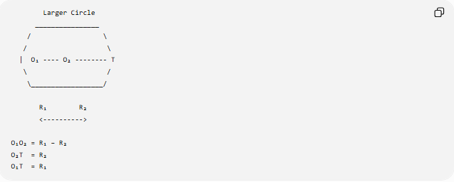
Larger Circle
________________
/ \
/ \
| O₁ ---- O₂ -------- T
\ /
\__________________/

R₁ R₂
<---------->

O₁O₂ = R₁ − R₂
O₂T = R₂
O₁T = R₁
The important relationship is:
$$\boxed{O_{1}O_{2}+O_{2}T=O_{1}T}$$
which gives:
$$\boxed{d+R_{2}=R_{1}}$$
and therefore:
$$\boxed{d=R_{1}-R_{2}}$$

Applications
# Source: AI Source: Provided by: [Data Path: Persons Table -> ID Column: 1, Name_En Column: Motasem Essam] -> From: [ChatGPT] on [7/25/2026]
Internal circle tangency appears in:
- Mechanical gears and circular components
- Wheels and rollers inside circular tracks
- Optical systems
- Circular packing arrangements
- Geometry constructions
- Robotics and motion planning
- Computer graphics
- Engineering design
- Mathematical models involving nested circles

Key Points
# Source: AI Source: Provided by: [Data Path: Persons Table -> ID Column: 1, Name_En Column: Motasem Essam] -> From: [ChatGPT] on [7/25/2026]
- Internal tangency occurs when one circle lies inside another and they touch at exactly one point.
- The two circles have exactly one common point.
- Their centers and tangency point are collinear.
- The tangency point lies beyond the smaller circle's center.
- The fundamental condition is:
$$\boxed{d=∣R_{1}-R_{2}∣}$$
- If $R_{1}>R_{2}$:
$$\boxed{d=R_{1}-R_{2}}$$
- The common tangent at $T$is perpendicular to the line joining the centers.
- Distinct equal-radius circles cannot be internally tangent.
- Internal tangency is different from external tangency:
$$\text{External: }d=R_{1}+R_{2} \\ \text{Internal: }d=∣R_{1}-R_{2}∣$$

Conclusion
# Source: AI Source: Provided by: [Data Path: Persons Table -> ID Column: 1, Name_En Column: Motasem Essam] -> From: [ChatGPT] on [7/25/2026]
Internal Tangency is the circle–circle configuration in which a smaller circle lies inside a larger circle and touches it at exactly one point. The defining geometric relationship is that the distance between the centers equals the difference between their radii:
$$\boxed{d=∣R_{1}-R_{2}∣}$$
This relationship, together with the collinearity of the two centers and the tangency point, completely characterizes internal tangency between two distinct circles.

